L6-W7-DBS301-Subqueries

–late means- no grade

# Name: Avinash Singh

**Course: DBS301**

**Prof. Ayesha Manzer**

**Date: 13-OCT-2017**

# Step 1 - Starting with Q4, copy the SQL and RESULTS to this file and submit

**Step 2: 1 to 3 is to be done before starting the questions from 4 to 10**

1 SET AUTOCOMMIT ON (do this each time you log on) so any updates, deletes and inserts are automatically committed before you exit from Oracle.

SET AUTOCOMMIT ON;

2 Make sure you exist as an employee with a NULL salary and 0.2 commission_pct in department 90.

SELECT employee_id

FROM employees

WHERE commission_pct = 0.2

AND department_id = 90

IT DOESN’T EXISITS – INSERTING NEW VALUE IN TABLE employees :

INSERT INTO employees

( employee_id,

first_name,

last_name,

email,

phone_number,

hire_date,

job_id,

salary,

commission_pct,

manager_id,

department_id

)

VALUES ( 207,

'Avinash',

'Singh',

'abc@xyz.com',

'647.646.1385',

'14-10-17',

'IT_PROG',

NULL,

0.2,

100,

90

);

3 Change the salary of the employees with a last name of Matos and Whalen to be 2500.

UPDATE employees

SET salary = 2500

WHERE last_name IN (‘Matos,’Whalen’);

**You must use subqueries for these questions (must minimize the number of tables being used in the main query)**

4 Display the last names of all employees who are in the same department as the employee named Abel.

SSELECT last_name

FROM employees

WHERE department_id = ( SELECT department_id

FROM employees

where last_name = 'Abel');

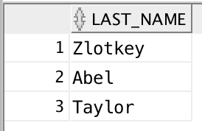

5 Display the last name of the lowest paid employee(s)

SELECT last_name

FROM employees

WHERE salary = ( SELECT MIN(SALARY)

FROM employees);

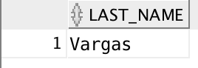

6 Display the city that the lowest paid employee(s) are located in.

SELECT L.city

FROM locations L, departments D, employees E

WHERE L.location_id = D.location_id

AND D.department_id = E.department_id

AND E.salary = ( SELECT MIN(salary)

FROM employees);

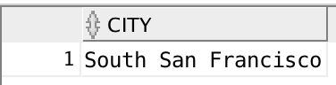

7 Display the last name of the lowest paid employee(s) in each department

SELECT LAST_NAME

FROM EMPLOYEES

WHERE (DEPARTMENT_ID, SALARY) IN ( SELECT DEPARTMENT_ID,

MIN(SALARY)

FROM EMPLOYEES

GROUP BY DEPARTMENT_ID);

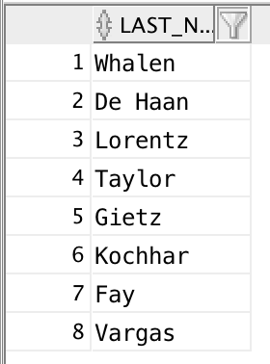

8 Display the last name of the lowest paid employee(s) in each city

SELECT LAST_NAME

FROM EMPLOYEES

JOIN DEPARTMENTS

USING (DEPARTMENT_ID)

JOIN LOCATIONS

USING (LOCATION_ID)

WHERE (CITY, SALARY) IN ( SELECT CITY,

MIN(SALARY)

FROM EMPLOYEES

JOIN DEPARTMENTS

USING (DEPARTMENT_ID)

JOIN LOCATIONS

USING (LOCATION_ID)

GROUP BY CITY);

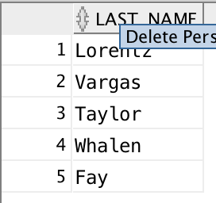

9 Display last name and salary for all employees who earn less than the lowest salary in **ANY department**.

Sort the output by top salaries first and then by last name.

SELECT LAST_NAME, SALARY

FROM EMPLOYEES

WHERE (DEPARTMENT_ID, SALARY) IN ( SELECT DEPARTMENT_ID, MIN(SALARY)

FROM EMPLOYEES

GROUP BY (DEPARTMENT_ID))

ORDER BY SALARY DESC, LAST_NAME;

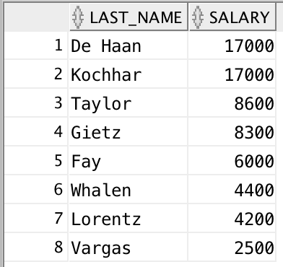

10 Display last name, job title and salary for all employees whose salary matches any of the salaries from the IT Department. Do NOT use Join method.

Sort the output by salary ascending first and then by last_name

SELECT LAST_NAME, JOB_ID, SALARY

FROM EMPLOYEES

WHERE SALARY = ANY ( SELECT SALARY

FROM EMPLOYEES

WHERE DEPARTMENT_ID = ( SELECT department_id

FROM departments

WHERE department_name – ‘IT’))

ORDER BY SALARY, LAST_NAME;

